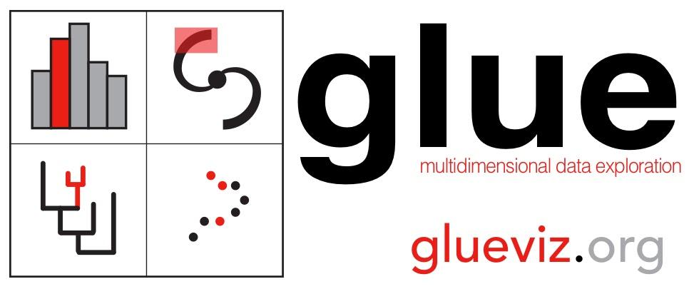

Welcome to the [glue software](http://glueviz.org/) demonstration at the 2020 Harvard DataFest.

This page holds a list of links and instructions that will be used during the live glue demo on 22 January 2020 led by [Catherine Zucker,](http://catherinezucker.github.io) [Prof. Alyssa Goodman](https://www.cfa.harvard.edu/~agoodman/) (glue PI), and [Mike Foley](https://scholar.harvard.edu/michaelfoley).

Links you should hold on to...

glue website: [glueviz.org](http://glueviz.org)

directory for all “demo” files, including this document: [tinyurl.com/glue-datafest-2020](http://tinyurl.com/glue-datafest-2020)

(If possible, download that full directory to your computer, and do not move files within the directory.)

A few minutes on what glue does…

* glue “overview” poster: [figshare.com/s/7aacc37dc44a0e410587](https://figshare.com/s/7aacc37dc44a0e410587)
* “glue in 2 minutes” video: <https://www.youtube.com/watch?v=qO3RQiRjWA4>

Make sure the core glue package AND plugins are installed.

* General glue installation instructions: [glueviz.org/install.html](http://glueviz.org/install.html)
* However, conda is **HIGHLY RECOMMENDED**. To install all the necessary plugins for this tutorial, use this conda command:

conda install -c glueviz glueviz=0.15 glue-wwt glue-geospatial glue-vispy-viewers

“Airplanes” Demo example…

**If you haven’t already synced/downloaded the airplanes directory, do that now, from** [**here**](http://tinyurl.com/glue-datafest-2020)**.**

**A step-by-step tutorial of the “airplanes” based demo is in this** [**PDF**](https://drive.google.com/open?id=1r8Hn2bcJpU2RLRsmfOQVIg7zJlIx0q2M)**.**

**You can also download the complete glue session produced by the tutorial** [**here**](https://drive.google.com/open?id=1mLvQ3S40N2MiROJLdpapTkC0-CH8QBNs)**.**

The airplanes demo can be used to learn these glue skills…

* Starting up glue
* Orienting yourself in the **glue dashboard**
* **Loading** data
* Making **2D images**
* **Linking** data
* Making **2D scatter plots**
* Making **2D and 3D selections**
* Creating new data attributes
* Making **histograms**
* Making **publication-quality plots**
* **Saving** your work

By the end of the tutorial, you’ll produce a session that looks like this! Yay!

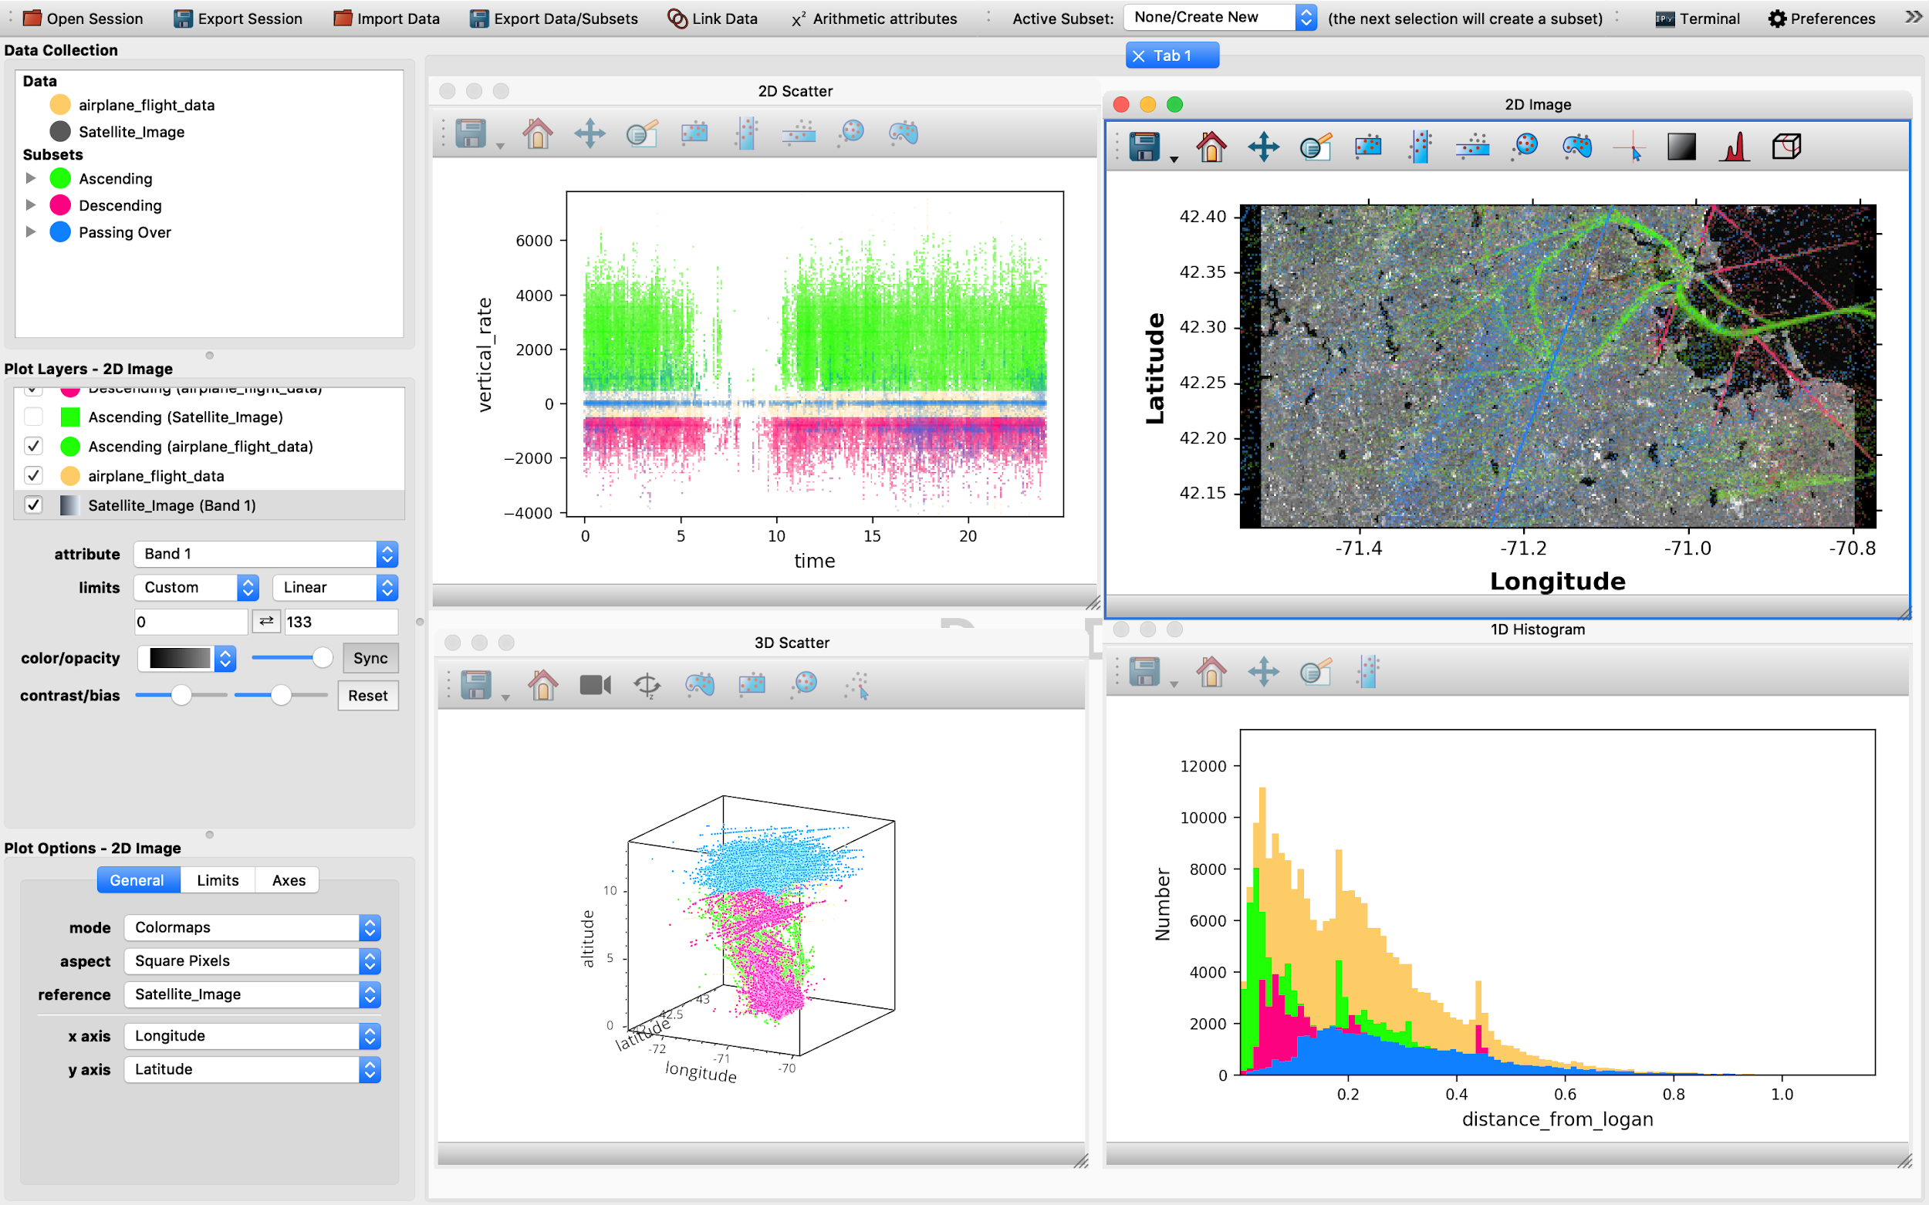

Comparison with tableau

Were you at the tableau session yesterday and want to see how glue compares? Check out our (in progress) [glue session of the tableau storm data](https://drive.google.com/open?id=1oyNcynC4iz6nz84xZgjP5ybuKcsNAsci)!

Feedback

Let us know (anonymously if you’d like!) how we did, by filling out this evaluation form!

<http://bit.ly/datafest_eval>